**TEST MANAGEMENT SYSTEM**

**A MINI PROJECT REPORT**

*Submitted by:*

**Group No: G24/T4**

Jaikirat Dev (2210990428)

Jaivardhan Khanna (2210990429)

Janvi Jain (2210990430)

Janvi Sethi (2210990431)

***in partial fulfillment for the award of the degree of***

**BACHELOR OF ENGINEERING**

*in*

COMPUTER SCIENCE & ENGINEERING



**CHITKARA UNIVERSITY**

**CHANDIGARH-PATIALA NATIONAL HIGHWAY**

**RAJPURA (PATIALA) PUNJAB-140401 (INDIA)**

May,2023

Group/Team no: G24/T4

Index

|  |  |  |
| --- | --- | --- |
| **Serial No.** | **Subject** | **Page No.** |
| 1. | Abstract | 1 |
| 2. | Introduction & Problem Statement | 2 |
| 3. | Technical Details & Key Features | 3-5 |
| 4. | Project Highlights | 4-6 |
| 5. | Conclusion | 7 |
| 6. | References | 7 |

**Abstract**

Online examination system is a web-based examination system where examinations are given online by using the internet on a computer system. The main goal of this online examination system is :

1.)To effectively evaluate the student thoroughly through a totally automated system that not only reduces the required time but also obtains fast and accurate results.

2.)To provide for a solution that can evaluate a person’s knowledge about the subject without the need of pen and paper.

3.)In order to motivate others to make similar projects by using the knowledge of their concepts.

**1**

**Introduction**

The name of our site is ‘‘*Padha.io*’’ and it has been deployed using HTML ,CSS , JavaScript and PHP .Our site enables a student/person to to be able to check the theoretical understanding of the concepts of the subjects he/she has chosen .And by doing so , a person can check if he/she has fully grasped the concepts or still needs to practice more .After completing the test ,a person can click on the submit button and then can be redirected to a page that showcases his/her marks obtained.

*Problem Statement*

A test management portal is to be designed using HTML, CSS and JavaScript. It is like a portal consisting of MCQs that can be based upon the subject the applicant chooses and based upon the right/wrong answers ,a score sheet with detail marks and information about the applicant can be maintained.

2

**Technical Details**

For the project I have used up a number of tags and functions from 3 Languages:  
1.)HTML

2.)CSS

3.)JavaScript

To link the CSS files to the HTML files,I have used “*link*” tag in HTML and for linking the JavaScript files ,I have used “*script*“ tag .

**HTML**

The main tags used in the HTML pages are :

#body :It comprises of the main visible part of the web page and can also contain other elements.

#div :It defines a division on the page and is used as a container for HTML elements

#button:It is used to make a user-interactable button.

#input:It is used to take input from user.

#form:It is used to submit the data entered by user.

#li :It is used to create elements in the form of a list.

#h1,h2,h3:It Is used to create headings of different sizes.

#head:It contains all info about the web page.

3

**CSS**

The main tags used in the CSS pages are :

#position :It is used to determine the position of an HTML element with respect to other elements or page.

#color :To give colour to text (used with background to give background colour).

#overflow:To define what happens to the content that is out of the defined width.

#‘:hover’:To determine what happens to an element when it is being hovered upon.

#border:Gives the element a border all-around.

#display :Determines the type of display of element.

#transition:Give animation effects.

**JavaScript**

The main API(s) used in the JavaScript files are :

#localstorage :It is used to store form data in the browser locally and can be used to get that data as well.

#getElementByID :It is used to access an element on the page by using its ***id*** *.*

#prompt:To make a pop-up box that can take input.

#alert:To make a pop-up box that displays a warning.

#confirm:To make a pop-up box that accepts only ‘*true*’ or ‘*false*’ as input-buttons.

#addEventListener() :To decide what happens when an event takes place on the selected element.

#.forEach:To access all elements in a list one-by-one.

4

**Key Features**

* **Front page** of the examination website is shown.
* A **login page** is formed for students to enter their required details for taking the exam.
* Student will be asked to enter a test subject before they can proceed further.
* After entering the subject ,students will be redirected to an *Instructions* page.
* After clicking the “*I Agree”* button ,a **MCQ based test** will be generated.
* Student can select options for the correct answer.
* **Time**rwill be shown on the top of the test page.
* **Result page** will be generated in the end.

*Advantages*

The advantages of a test management system are :

* It helps a candidate in grasping the subject .
* It can increase the versatility of the candidate’s knowledge by allowing him/her to opt and give test for different subjects.
* It can help a candidate improve from his/her mistakes.

**5**

Project Highlights

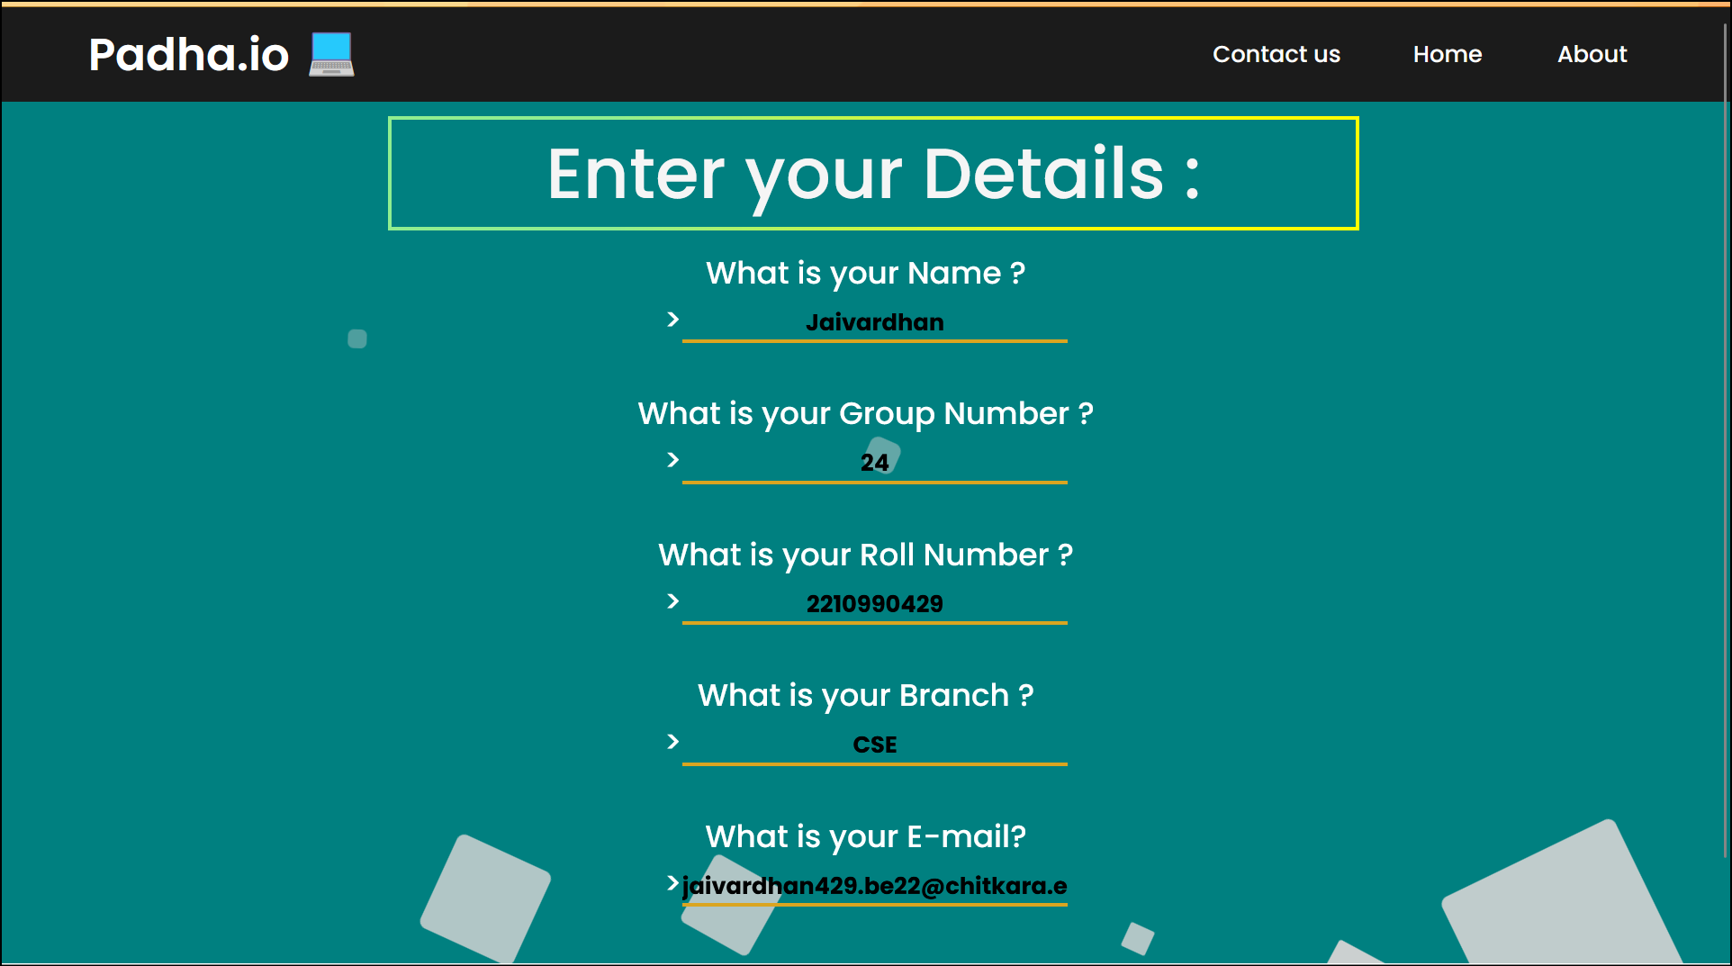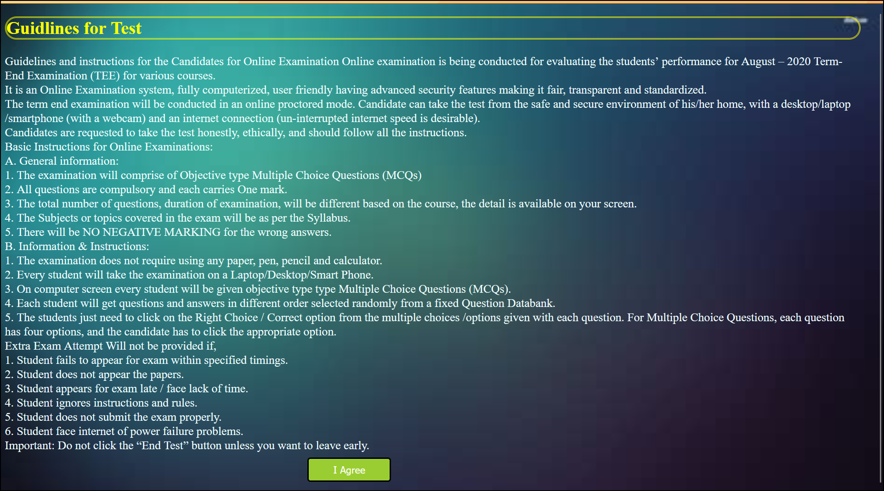

**5**

6

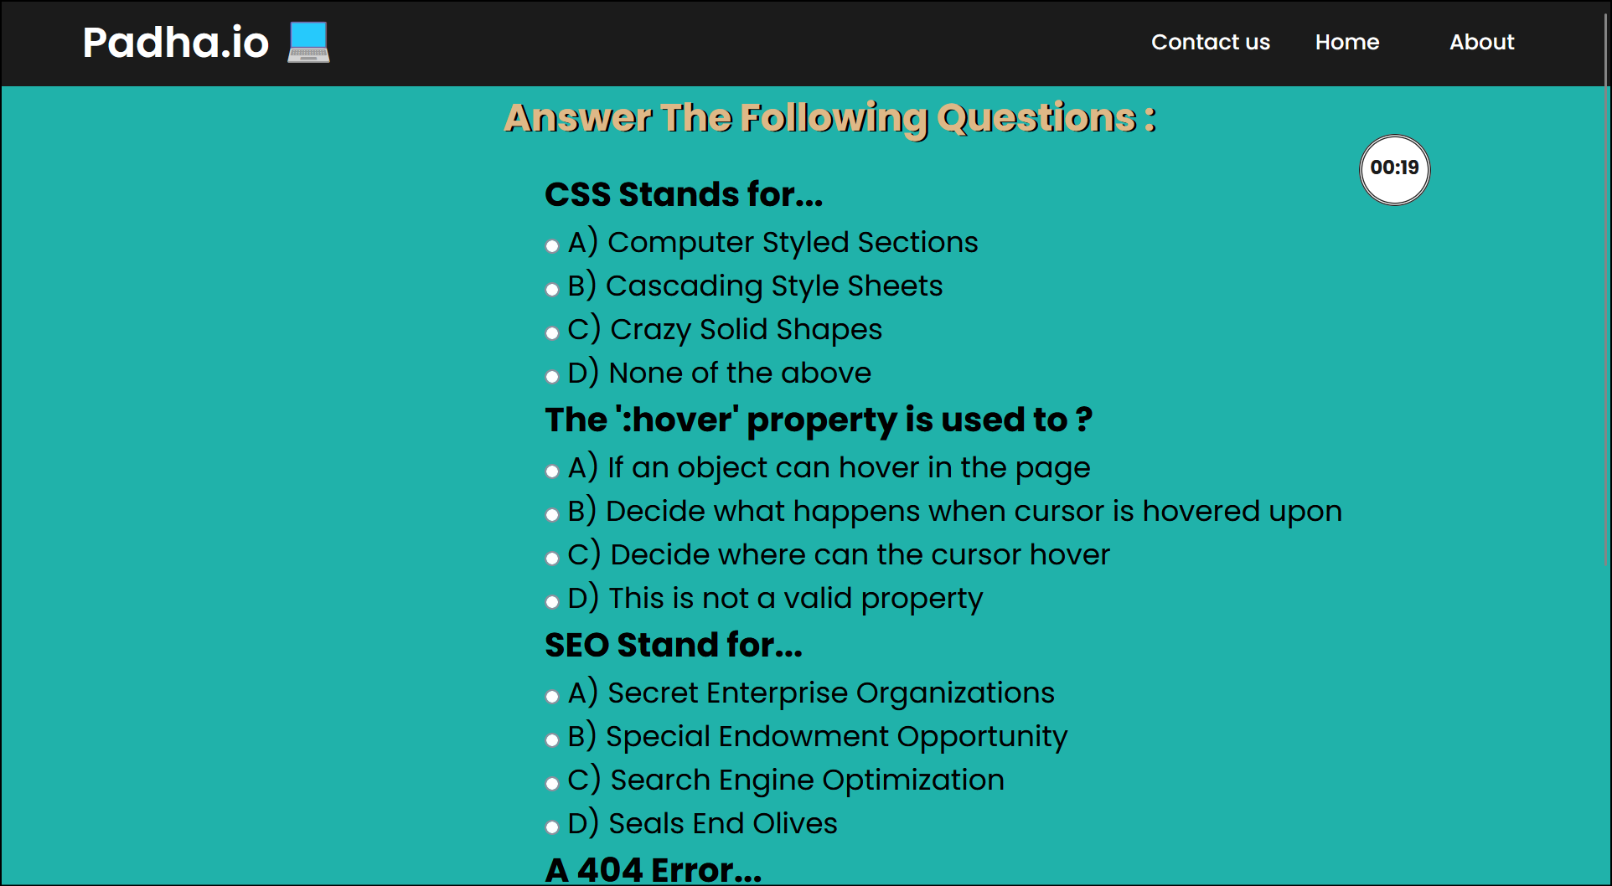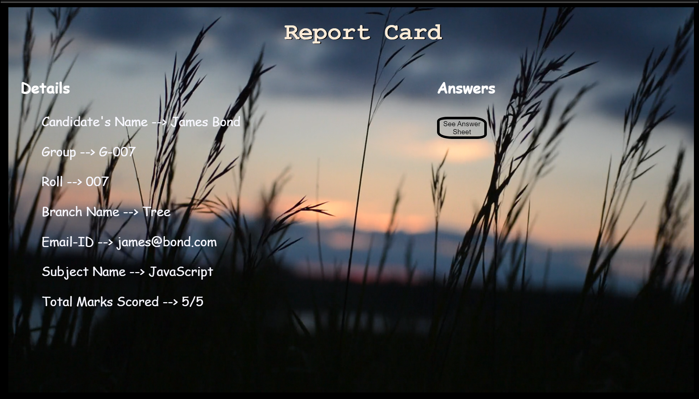

7

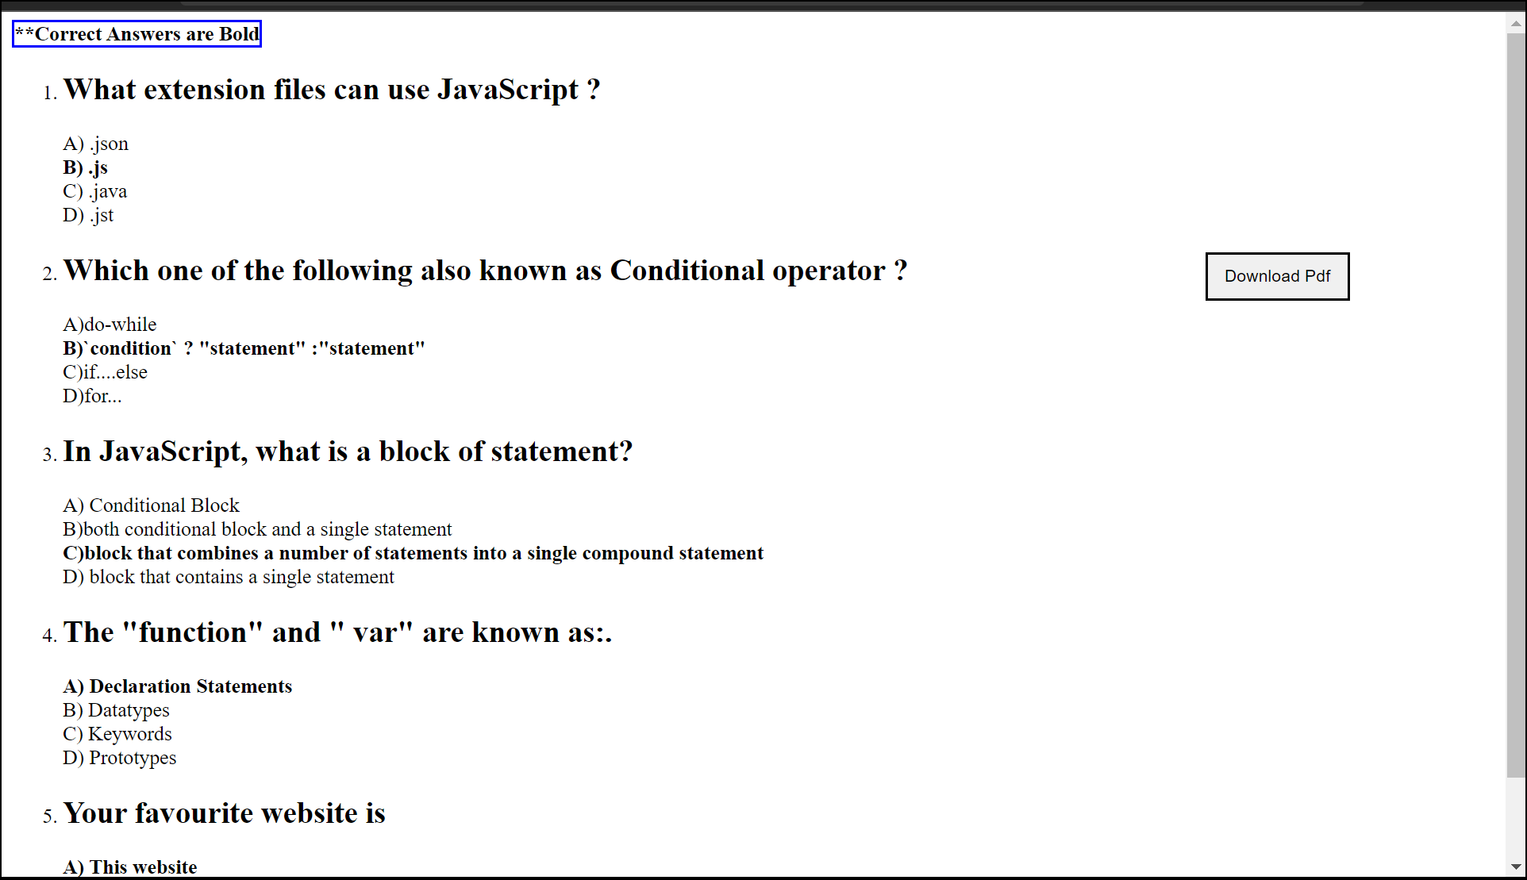

8

**Conclusion**

* With the completion of this project we conclude that it has achieved its purpose.
* The whole project provides a base for students to take their exam using the web site.
* The system is developed using HTML, CSS ,PHP and JavaScript programming language.
* Online examination is better as compared to paper-based exam.
* The automated system helps students and lecturers to save time and makes the process faster.
* It is also more environmental .

**References used:**

* [https://www.w3schools.com](https://www.w3schools.com/)
* [https://Mozilla.org.com](https://mozilla.org.com/)
* [https://practice.geeksforgeeks.org](https://practice.geeksforgeeks.org/)
* [https://codescholl.com](https://codescholl.com/)

**Books**[**:**](https://www.w3schools.com/)

* ‘*Web Enabled Commercial Application Development using HTML, JavaScript, DHTML and PHP*’ by Ivan Bayross, 4th Edition, BPB Publications.
* ‘*The Complete Reference HTML & XHTML*’ by Thomas Powell, 5th Edition, Tata McGraw-Hill Company Limited.

**9**